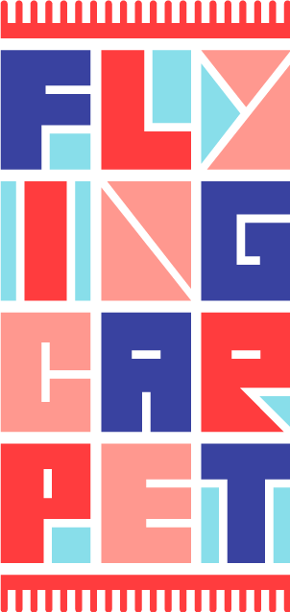
Flying Carpet Festival
Contact:
Sahba Aminikia (Artistic Director and Founder)
sahba@flyingcarpetfestival.org
www.flyingcarpetfestival.org
- Performances during September 15th-25th, 2023
- Location: Turkey, Turkish Syrian border (Mardin, Midyat, and Diyarbakir)
For Immediate Release:
The fifth Flying Carpet Festival will be returning to the Turkish Syrian border between September 15th-25th, 2023 and be held in remote villages and cities near the border in Mardin, Diyarbakir and Midyat during a 10-day residency for 31 artists from 17 countries.
Flying Carpet Festival is the first mobile multi-disciplinary arts festival for vulnerable and refugee children living in difficult places worldwide. The Flying Carpet Festival was created in 2018 by Sahba Aminikia, a San Francisco-based Iranian American music composer, in collaboration with Her Yerde Sanat Dernegi (Art Anywhere Association), founded in 2012 by Pınar Demiral and Serdal Adambb, an Non-governmental organization, a social circus school and a cultural organization based in Mardin, Türkiye, near the Turkish Syrian border where 3.6 million refugees, half of whom are children are resettled. Other programs held by Her Yerde Sanat Dernegi include; Sirkhane (circus and acrobatic workshops), Sirkhane Darkroom (analog photography workshops), and Müzikhane (music workshops).
The festival annually brings 30-35 artists, musicians, dancers, acrobats, and storytellers to the Turkish Syrian border as part of an artist residency. It engages them in creating a cohesive artistic story-telling experience decorated with music, dance, circus arts, and visual projection for children of Syrian, Turkish, and Kurdish origin. The festival forms collaborations between artists-in-residence, local artists, and children artists.

Since its conception, The Flying Carpet Festival has reached out to 18,000 children through 46 live performances, 260 workshops and has hosted 96 artists. It also has been mentioned in San Francisco Chronicle, NPR, Associated Press, KALW, Medium, and I Care if You Listen. In the previous years, Flying Carpet has been sponsored by the United States Embassy in Adana, BMZ (German Federal Ministry of Economic Cooperation and Development), MEROPS Foundation, and the Italian Cultural Institute in Istanbul.
The artist lineup this year includes, Kevork Mourad (visual artist, USA/Syria), Kelsey Heimeman (visual artist, USA), Sarah Dawson McClean (photographer, USA), Raffi Chilingirian (Duduk player, Lebanon), Harshal Vyas (dancer, India), Samia Karimi (Dancer, Afghanistan/USA), Cansu Akdeniz (puppet designer, Turkey), Gabriel Meidinger (violinist, France/Turkey), Hanna Nikalayeva (face artist, Belarus), Nandala Mathew (dancer, Uganda), Cynthia Dragoni (dancer, USA), Avin Ahmadi (Oud player, Iran), Lydia Umlauf (USA), Julie Michael (violist, USA), Tonka Uzu (illustrator, Bulgaria/UK), Aaron Kierbel (drummer, USA), Stephanie Arnold (cellist, Australia), Luther Bangert (circus artist, USA), Sabina Kariat (animator, USA), Sautier Thibault (circus artist, France), Micaela Bottari (vocalist, USA), Hans Blichert (bassist, Canada/USA), Yavuz Tilek (composer, Turkey), Nora Gharyéni (vocalist, Tunisia), Gabrielle Tesfaye (USA/Ethiopia), Rojda Orhan (Germany/Portugal).
The production artist team this year includes Nima Dehghani (visual projection artist - Iran/United States), Özgür Mert (videographer - Turkey), Shayan Shariat (stage designer, Iran), Torfeh Ekhlasi (puppet designer, Iran), Kamelia Rashidi (light designer, Iran/France) and Berna Küpeli (photographer - Turkey).
Flying Carpet Festival Website
Official Announcement Video
Photo Gallery
Instagram
Facebook

